Assignment 2
(Last date for submission is 18th March 2015)
If the assignment is not submitted within the deadline you will get 0 (Zero) marks for this assignment.
- Demand function is given by Qd=160000-1000P
Calculate the following values in the table:
Price (Rs) | Quantity (Q) | Total Revenue (TR) | Marginal Revenue  MR=d(TR)/dQ | Point Price Elasticity  Ep=dQ/dP*Q/P
160
150
140
130
120
110
100
Use Graph Paper
(a)In Y-axis plot TR and in X-axis plot Q . Observe how the total revenue of the firm is changing.
(b)Again Plot Price (P) per unit in the Y-axis and Quantity demanded (Q) in the X-axis to draw the Demand Curve of the Product.
(c)In the same graph (2)above, Plot the MR in the Y-axis against the Q in the X-axis.
Interpret your graphical presentation, when TR is maximum? Ep= ? and MR = ?
(d)If Supply function is Qs=10000+2000P Calculate Equilibrium Price (Pe) & Equilibrium Quantity (Qe)
2. If the elasticity of demand for a commodity is estimated to be -1.5, if price is decreased from $2.10 to $1.90 calculate the percentage increase or decrease in quantity demanded. Use arc elasticity method.
3.For a demand function Q=15000-50P, compute the price and quantity demanded at which Total Revenue is maximum. Also compute the Maximum Total Revenue.
4. 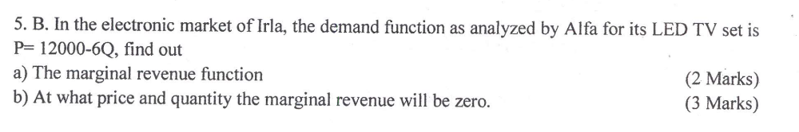
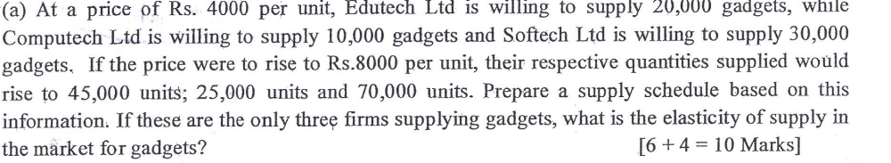

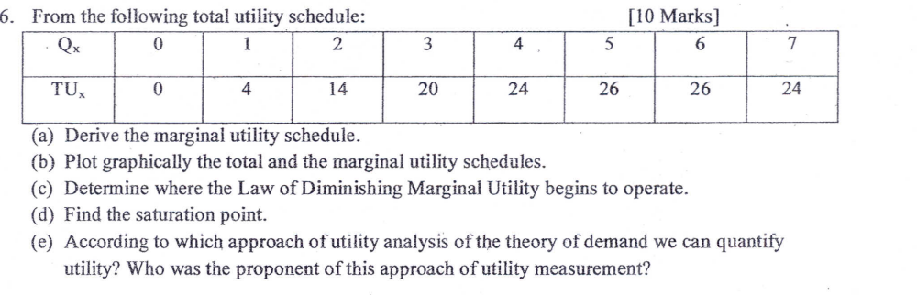
7.The total revenue function of a particular good is given by TR= 120Q -0.1Q²
(a) Over what output range is demand elastic.
(b) Initially price is set at Rs. 71.60.
To maximize revenue should price be increased or decreased. Explain.

